On the Road to Emmaus Younger KLKids 26-4-2020

After the soldiers had killed Jesus and he'd been put in the tomb, God had made him alive again.
On that wonderful Easter Morning, two of Jesus' friends were walking home from Jerusalem, to a small town named Emmaus. It wasn't a very long walk, it would take them just a couple of hours.
As they walked, they were talking about the things that had happened while they were in Jerusalem - Jesus riding into Jerusalem on a young donkey with the crowds of people waving tree branches and shouting praise to God, "Welcome to our King Jesus". Then how the soldiers had arrested Jesus, and how the religious leaders, who were jealous of Jesus' popularity, had turned some of the people to want Jesus killed, and then it had happened. He really was killed - and these disciples of Jesus were very, very, sad. They had thought that Jesus was really God's Son and that he would be their king forever - but now, he was dead !
As these two disciples walked along, feeling miserable, another person was walking along to Emmaus as well, and it appeared that he was going to pass them by, but he didn't, he joined them as they walked.
"Why are you two so sad?" he asked them.
One of the friends, the one named Cle-o-pas, answered him, "You must be a stranger around here. Otherwise you'd know about the sad things that happened to Jesus of Nazareth. He was sent to us from God, he taught us wonderful things about God, and he did great miracles - we thought that he would free us and all Israel from the Roman soldiers, and that he'd become our great king. But instead, he was arrested and killed.
"And now, three days after he was killed, no one can find his body. Some of the women who are friends of ours say that they went to the tomb early this morning, where he was buried and angels told them that he is no longer dead ! And not only that, angels told them that he is alive now. Some of our men went to the tomb afterwards - they didn't see any angels, but they couldn't find his body either.
Jesus must have felt so sad for his friends -- because that's who the stranger was, Jesus. -- As they walked along He reminded these two friends about all the things the Bible said would happen to the Saviour when God sent him to earth. But still these two friends didn't realise that it was Jesus talking to them.
They soon reached Emmaus and the house where the two friends were staying and, seeing that it was nearly evening, and getting dark, they invited the "Traveller" to come inside with them, share their evening meal and stay the night. Then he could set out again in the light of morning.
So they all went into the house, and sat down to eat their evening meal.
At the meal, the traveller - Jesus - took the small loaf of bread and after he had thanked God for it, he broke it and handed it to the other two. As he did this, the friends suddenly recognised Jesus -and then he disappeared from them.
They said to each other, "Didn't we feel warm inside while he was talking to us as we walked along, all the time explaining what the Bible said about God's promised Saviour?"
They couldn't keep this wonderful news to themselves, so even though it was now dark, and not really safe to travel at nightime, they straightway started back to their friends in Jerusalem.
"We have seen Jesus !" they told them, "He talked lots to us, but it was only when he said a blessing over our food that we suddenly recognised him."
And just as they were telling this to the other disciples, Jesus suddenly appeared among them, and talked to them all. How exciting for them !

- What are some of the things that had happened to Jesus in Jerusalem?
- How many of his friends were walking home from Jerusalem to Emmaus?
- What were they talking about?
- When another traveller joined them in their walk what did he talk to them about?
- What part of the meal was it that the 2 friends recognised the traveller to be Jesus?
- Did they just stay home after that? What did they do?

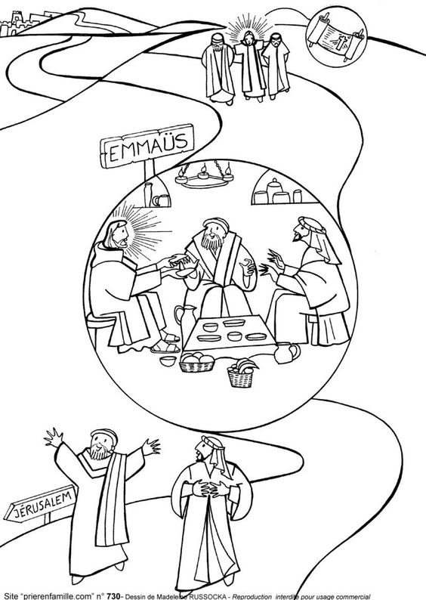
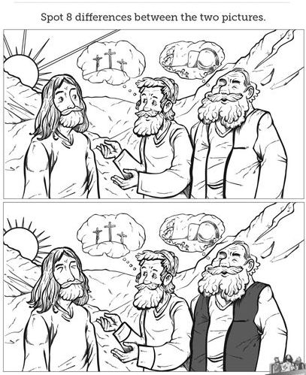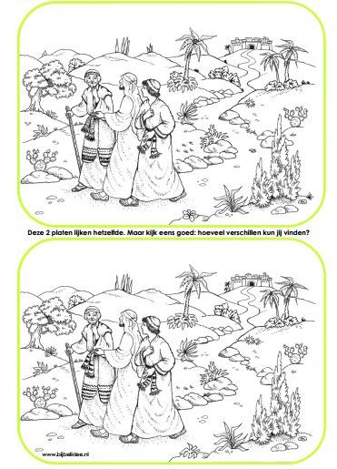

Find 8 changes that have been made to the 2nd picture.
Find 12 changes that have been made to the 2nd picture.
G'day Younger KL Kids Mums and Dads. It's pretty obvious as to this Sunday's Bible teaching.
I'm hoping that both you and your kids have enjoyed the Easter series.

One of the emphases of this lesson is that the 2 disciples recognised Jesus as he said the blessing over their food.
Here are some Hebrew blessings:
This is the Hebrew blessing to thank God for bread: Probably what Jesus said,
"Blest are You, Lord our God,
Ruler of the universe, who brings forth bread from the earth."
Barukh ata Eloheinu melekh ha’olam hamotzi lehem min ha’aretz.

And for Wine & Grape Juice:
"Blest are You, Lord our God,
Ruler of the universe, who creates the fruit of the vine."
ata Adonai Eloheinu melekh ha’olam borei p’ri hagafen.

And for Fruit:
Blest are You, Lord our God,
Ruler of the universe, who creates the fruit of the tree.
Barukh ata Adonai Eloheinu melekh ha’olam borei p’ri ha’eitz.
And for Vegetables:
Blest are You, Lord our God,
Ruler of the universe, who creates the fruit of the ground.
Barukh ata Adonai Eloheinu melekh ha’olam borei p’ri ha’adamah.

And for Grains - rice, wheat, corn, etc
Blest are You, Lord our God,
Ruler of the universe, who creates varieties of nourishment.
Barukh ata Adonai Eloheinu melekh ha’olam borei minei mezonot.

And for miscellaneous foods - meat, poultry, eggs, fish, dairy products, sweets(lollies)
Blest are You, Lord our God,
Ruler of the universe, at whose Word all came to be.
Barukh ata Adonai Eloheinu melekh ha’olam shehakol niyah bidvaro.
Perhaps this week you could teach your kids some new graces, thankyou prayers, for them to pray before mealtimes

"We thank You Lord our God
with hearts and hands and voice
For wondrous gifts You've given
in which our hearts rejoice. Amen"

"For the food we are about to eat,
Lord we are truly thankful. Amen"

"Come Lord Jesus, be our guest
and let these foods to us be blest. Amen"

"Bless us O Lord and let our food
strengthen us to serve You. Amen".

"We bless You O Lord,
for all these Your gifts
And please supply the needs of others too. Amen"

"You are great
and You are good
We thank You Lord for this our food.
By Your hand
must all be fed
We thank You Lord
for our daily bread. Amen

